Name: NYIRUMURINFA Kenny Fabrice

ID: 22975

**WEB TECHNOLOGY FINAL PROJECT**  16th, December, 2023

**TOPIC: Job board platform for connecting job seekers with employer’s system**

**Work Submission**

1. **Project Requirement**
2. **Purpose of the project**

The purpose of a job board platform for connecting job seekers with employers is to provide a centralized and efficient system for job matching and recruitment. The project aims to create a digital platform where job seekers can find relevant job opportunities and employers can reach a wide pool of potential candidates. The platform increases the visibility of job opportunities for job seekers, especially those who may not have direct access to a wide network of employers. It provides a centralized hub where employers can showcase their job openings and reach a larger audience of potential candidates. And also The platform allows job seekers to explore a wide range of job listings conveniently. It provides search and filtering functionalities to help job seekers find job opportunities that match their skills, qualifications, and preferences.

1. **Expected outcomes of the project**

The platform should provide a wide range of job opportunities from various industries, increasing the chances for job seekers to find suitable employment options. By using advanced matching algorithms and filters, the platform can facilitate better matches between job seekers and employers, leading to more successful and fulfilling job placements. The last one The platform should provide equal access to job opportunities for all users, including those who may face geographical or networking limitations. It should also enhance the visibility of job seekers' profiles and qualifications, helping them stand out to potential employers.

1. **Key Functional Requirement of the project**

* **User Registration and Profiles:** Users can register as job seekers , operations manager or employers and create profiles with relevant information such as personal details, contact information and his/her roles.
* **Job Listings:** Employers can post job openings on the platform, including details such as job title, location, description, requirements, and application guidelines and also his/her name. Job seekers can search and browse through available job listings.
* **Job Search and Filtering:** this platform allow Job seekers to search for jobs based on criteria like keywords, location, industry, experience level, experience, job title and salary level. The system provides filtering and sorting options to help users find relevant job opportunities.
* **Application Submission:** Job seekers can apply for jobs directly through the platform by submitting their resumes, cover letters, and any other required documents specified by the employer through the company email. The company receive and manage applications within the system.
* **Communication and Notifications:** The system facilitates the user notifications by allowing the user to receive a notification after he/she send or apply something.
* **Dashboard:** The platform typically includes dashboard that allows administrators to manage user accounts, job listings, site settings, and monitor system activities.
* **Login Page:** the platform allow the user to access the login page which redirect you to the dashboard according to user roles.
* **Forgot and Reset Password:** the platform allow user to reset his/her password when he/she forgot it by confirming his/her email and phone number then he/she can set the new password.
* **Pagination :** the platform will allow the user to choose the page he/she want to load and he/she can navigate the page by using next, previous, last and first page.
* **Error- Handling**: the platform will allows user to see the error messages if the platform catch an error and exception.
* **File upload and Download:** the platform will allow the user to download and upload his/her documents.
* **Validation:** the platform will allow the user to catch error messages when he/she fills in with incorrect credentials or data.

1. **Key Non-Functional Requirement of the project**

* **Reliability:** job seekers can access their resume 98% of the time without failure.
* **Availability**: System should be highly available and accessible for users anytime the job seeker needs a job recommendation. The system must always be available 24/7 and remain responsive despite failures which may occur.
* **Security:** System should be secure. Only the operations manager and employer the ones who play the role of admin are the one who can view jobseeker’s information like passwords
* **Authentication:** the system may not grant the job seeker who entered a weak password, the customers must provide a strong password with 8 characters including letters and numbers in order to prevent them from hackers’ attacks
* **Data integrity:** the system shall maintain data integrity by keeping backup of all updates to the database for every record transaction
* **Usability:** the UI has to be user-friendly and easy to use
* **Compatibility:** The system should be compatible with different operating systems and software platforms, like browsers, since a customer can access it using any type of operating system or/and browsing software. Such as Windows OS, Ubuntu OS, Android OS, iPhone OS, etc.
* **Maintainability:** A job board platform requires ongoing maintenance, updates, and technical support to ensure its smooth operation. Allocating resources for bug fixes, feature enhancements, and user support will be necessary to address any issues or limitations that arise.
* **Recoverability:** The system should be able to Recover data if it’s lost, backup must exist
* **Performance:** The User Interface (web site)’s load time should not be more than 3 seconds for users
* **Robustness**: A robust system is able to handle error conditions gracefully, without failure. This includes a tolerance of invalid data, software defects, and unexpected operating conditions.

**ii. Project Plan**

1. **SCOPE**

The scope of this project is bounded to the connection between job seekers and employers in Rwanda. The platform should allow job seekers and employers to register, create profiles, and authenticate themselves to access the platform's features and services. And Job seekers should be able to search for job listings based on various criteria such as location, job title, category, experience level, and keywords. The platform should provide filtering and sorting options to help job seekers find relevant job opportunities.

1. **TIMELINE**

This job platform application was developed in a period of one week and a half(12days), requirement gathering took me 1 day, design and prototyping took me 3 days, development and coding took me 6 days, testing the application 1 days and the deployment took me 1 day.

1. **Resources**

Resources I used are:

**Programming Languages and Frameworks:**

Backend Development: JAVA

Frontend Development: HTML/CSS, JavaScript, THYMELEAF Engine.

Database Management Systems: MySQL Work Bench, SQL

Framework: Spring MVC, Spring Boot, Spring Data JPA

**Web Development Technologies and Tools:**

Integrated development environments (IDEs) (e.g., IntelliJ, Visual Studio Code)

**Hosting platforms** (e.g., Heroku)

**Iv. Database Schema**

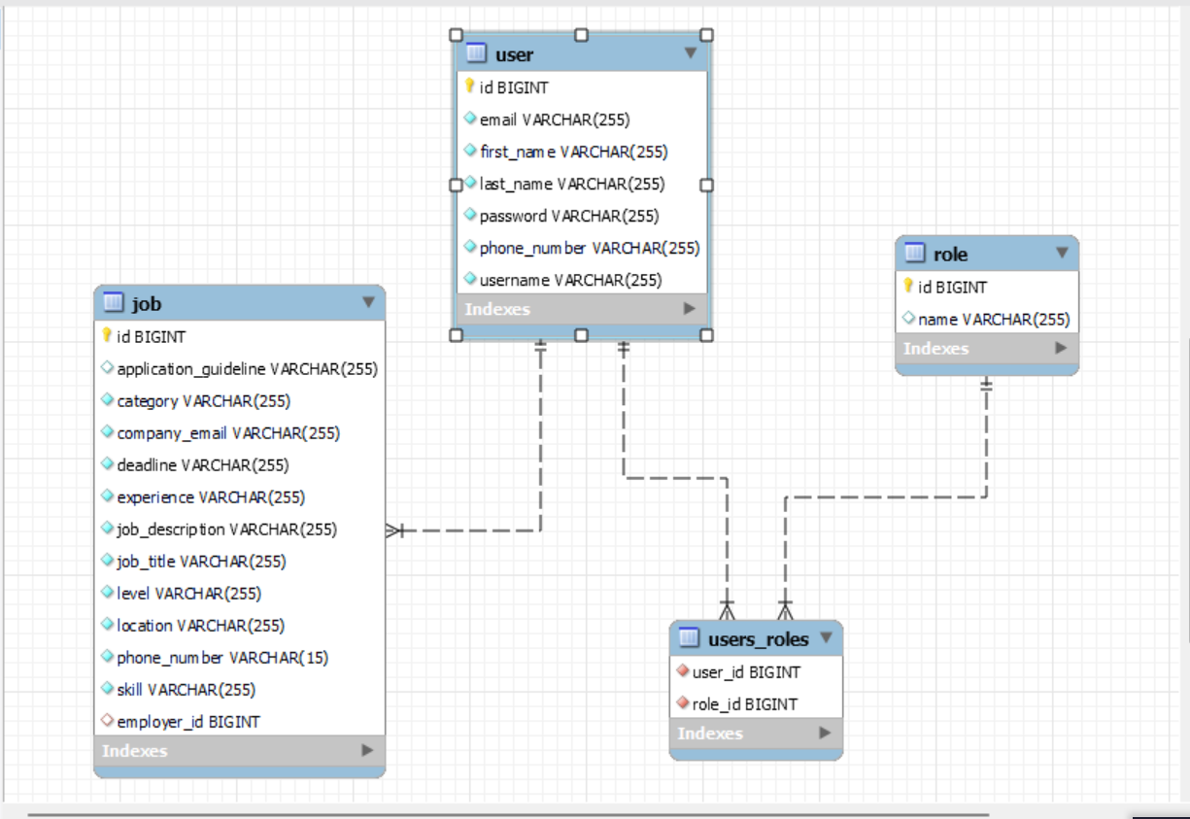

Users are mapped to their role by ManyToMany relationship.Each

Job is mapped to the responsible Employer by ManyToOne relationship.

**V . User Documentation**

**To access my App use**

**Login credentials**

**Role: EMPLOYER**

* Email: munezerowilly6@gmail.com
* Password: fun123

* Phone number (for reset password): 0798345672

**Role: JOB SEEKER**

* Email: kenntyfabrice8@gmail.com
* Password: fun123

* Phone number (for reset password): 0783445678

**Role: OPERATIONS MANAGER**

* Email: [susan@gmail.com](mailto:mary@gmail.com)

* Password: fun123
* Phone number (for reset password): 0788967354

To access my Job Board Platform use this link <http://localhost:8060/showMyLoginPage>

This will take you to the Login Page

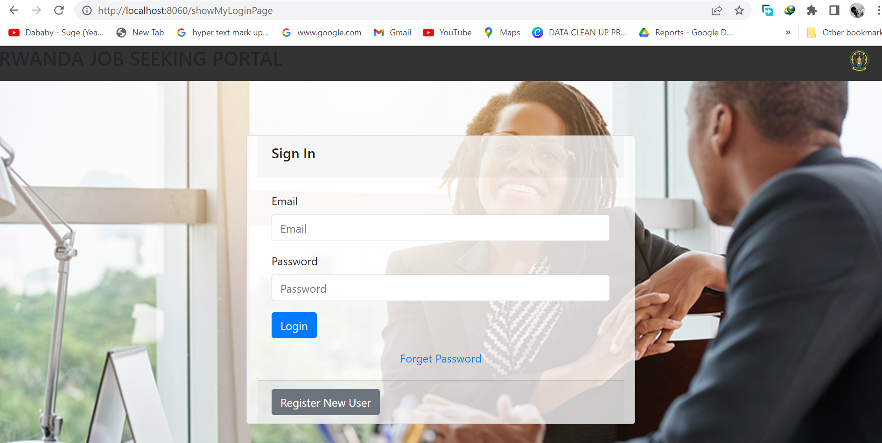

Register new user form



In case the new user get registered successfully you will get a short notification on the page



When you try to submit the invalid form in the register form you will receive error messages because of spring Validation. The user with the role of operations manager is the on to register new user.

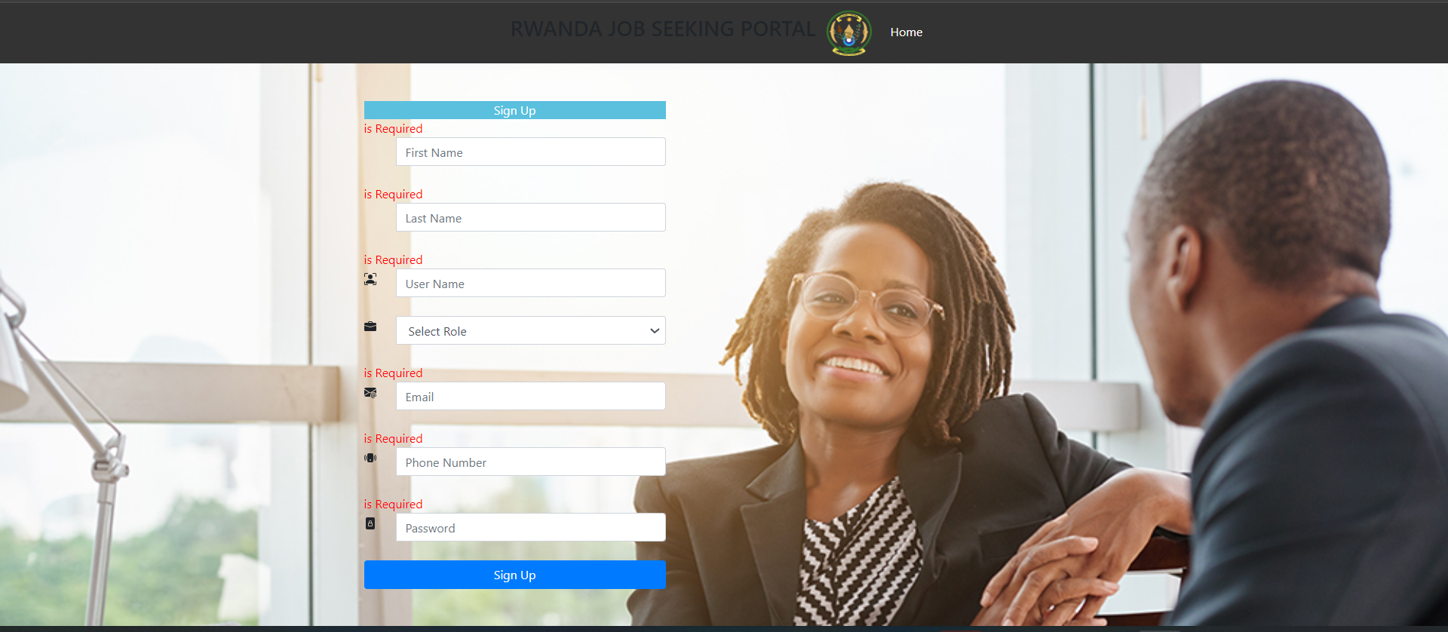

On the Login form there is an option for a user who forgot his/her password he/she will click the link of forgot password. He/she will be taken to the page for confirming if it’s his/her account by filling email and phone number

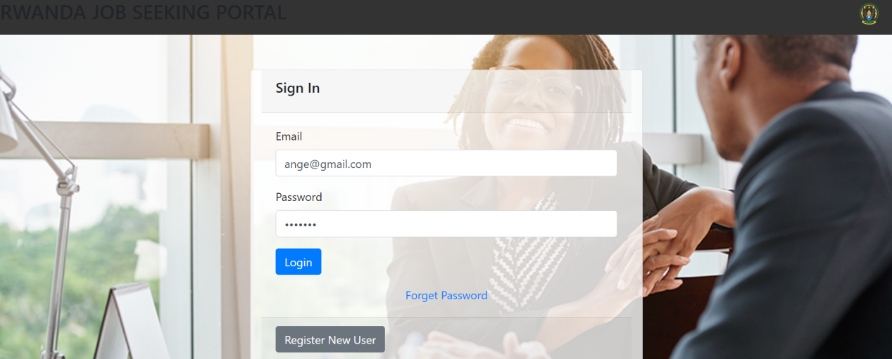

Click forgot password

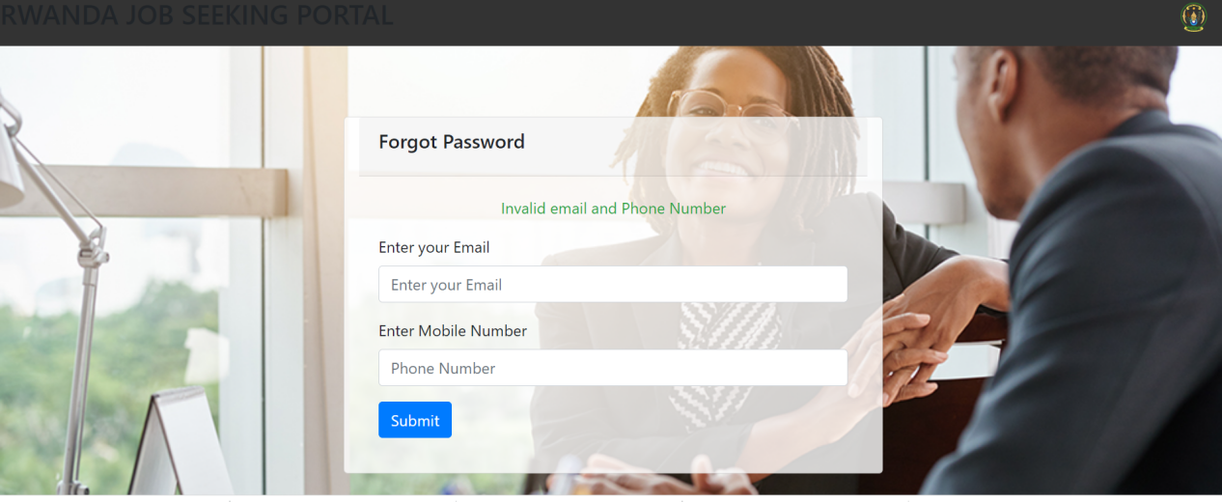

If you put wrong credentials it will display invalid email and phone number ,and if the credentials are correct it will redirect you to the reset password to set new password

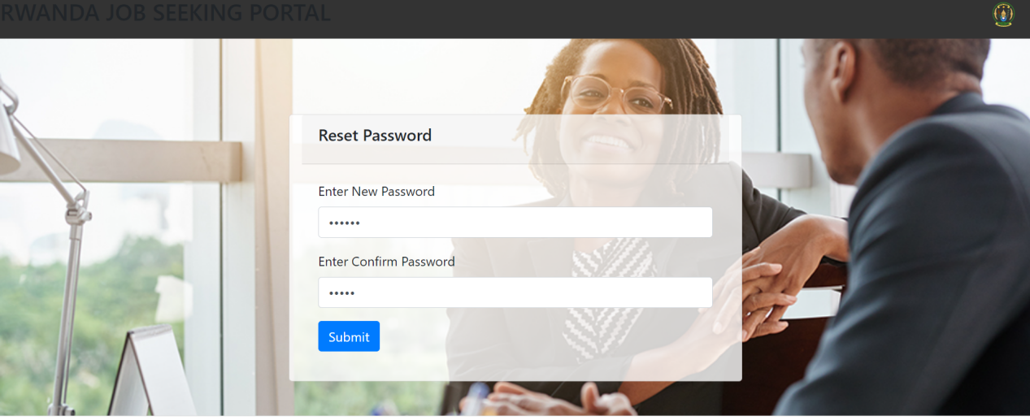

And if you put new password which doesn’t meet the confirm password you will get an error message

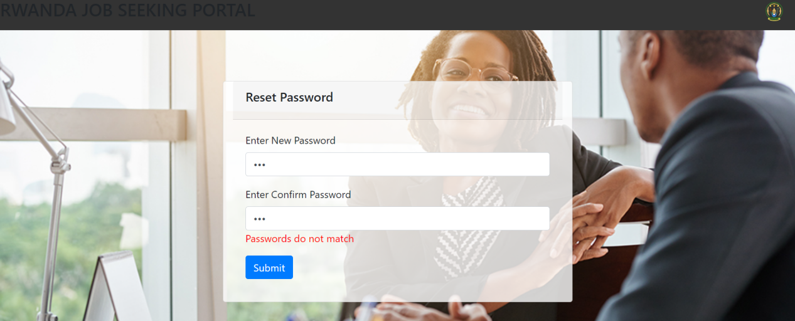

And you password matches it will be updated in the database

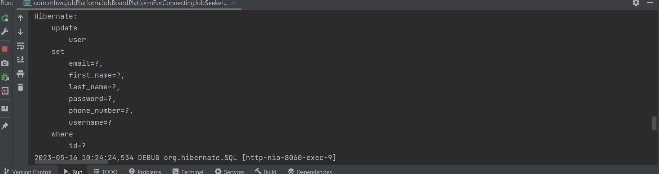

**Accessing the Dashboard**

Using Spring role based security users will get different dashboard because of their roles if they try to Login

**Role Operations Manager(Admin) Dashboard**



he/she will be able to see available jobs, add job and register new User

**Role Job Seeker Dashboard**



He/she will only have access to view available jobs only

**Role Employer Dashboard**



The employer will have access to add new jobs by clicking Add Job

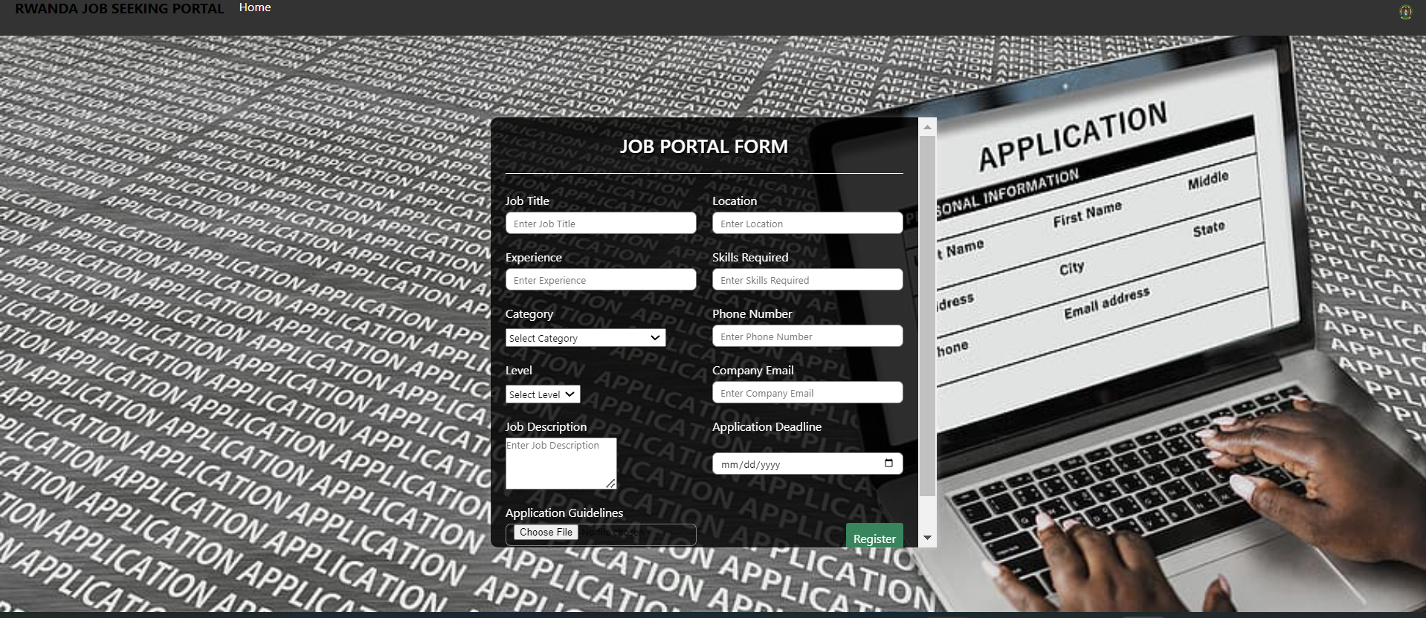

After saving new Job he/she will get notified by getting confirmation message



**Listing Available Jobs**

By clicking on Available Jobs you will be able to search for a job by filtering according to the data you have or use a keyword. And also user is able to navigate pages by clicking on next, previous, last and First page. And also user can see the total available jobs

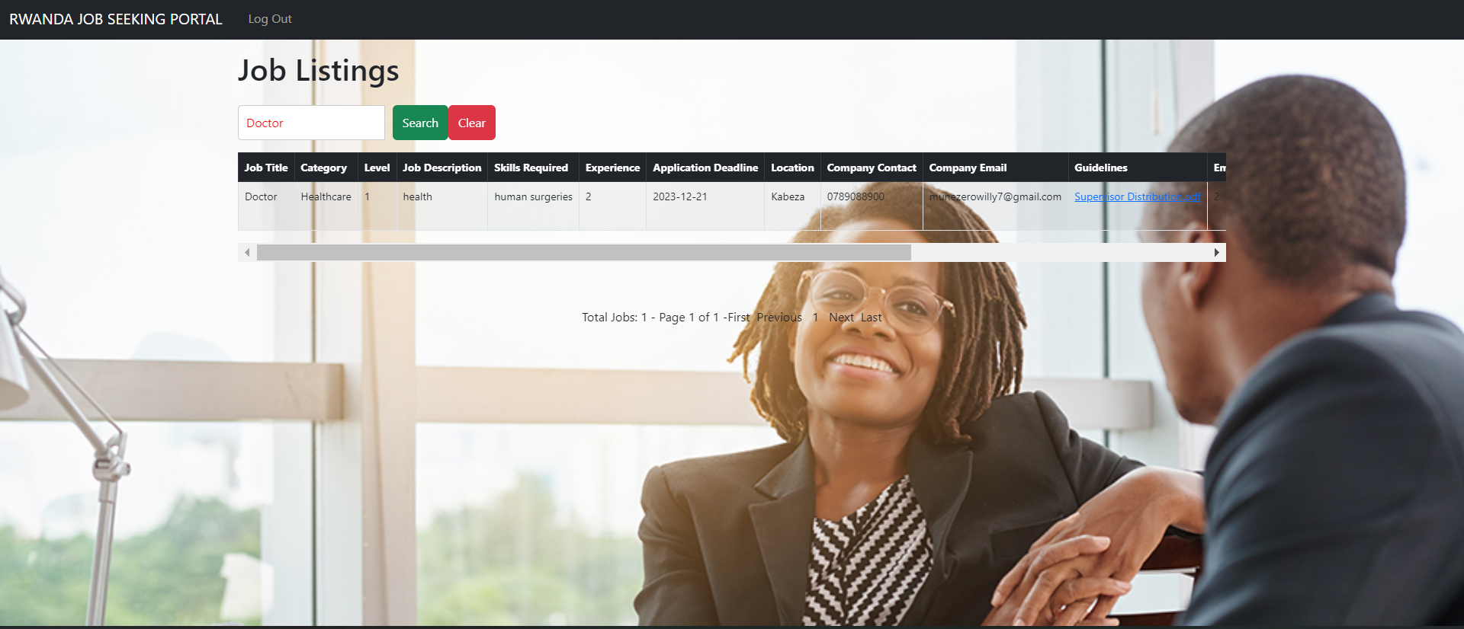

Pagenation

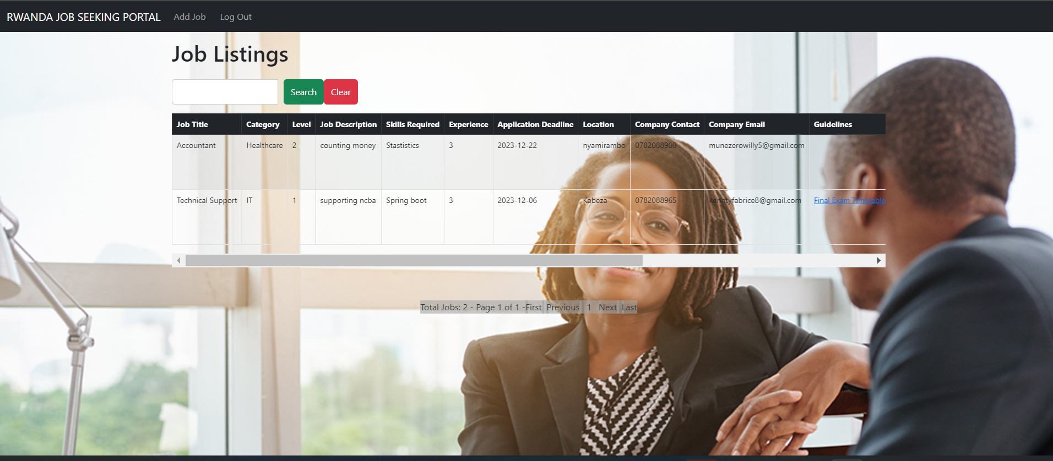

On page 2 is where you can find the public service

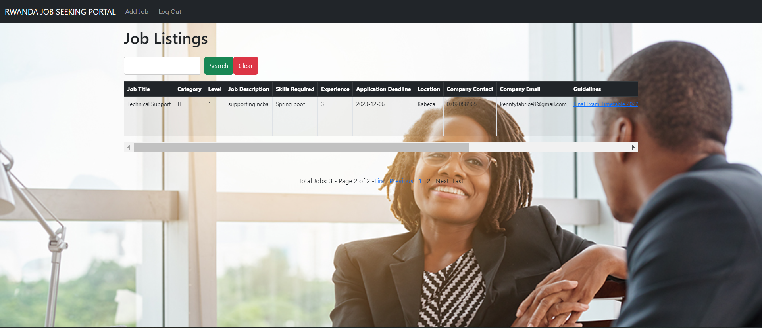

For Spring based roles security user with **ROLE_JOB_SEEKER** he/she will not be able to see the Add Job and DELETE AND UPDATE BUTTON

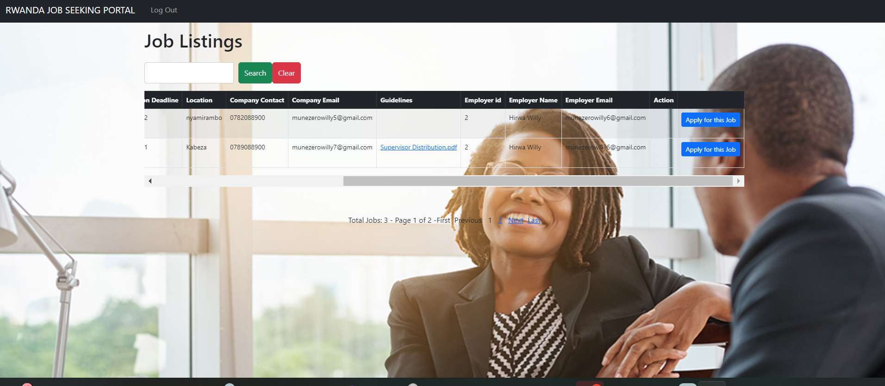

The JOB SEEKER if he/she want to apply for the job he/she will click apply for this job and the company will receive a short email that someone applied for their positions

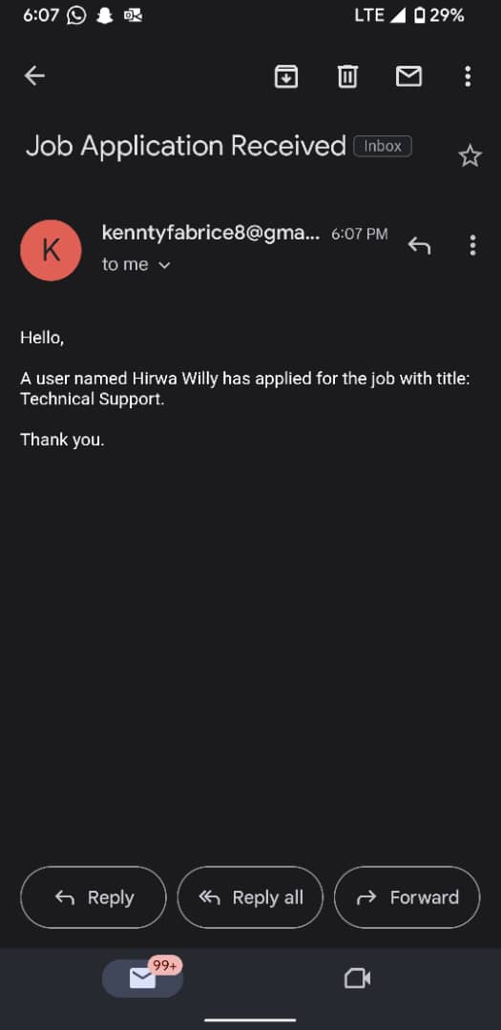

the JOB SEEKER can download the application guidelines that shows the requirement

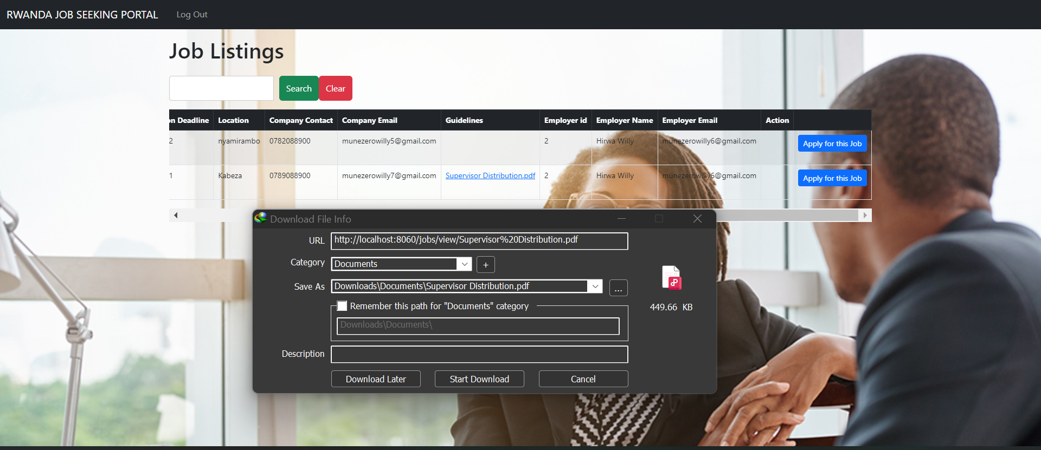

**User Access Management**

A user with a role of Operations Manager is able to manage all users in the system where he/she can approve or reject user account.

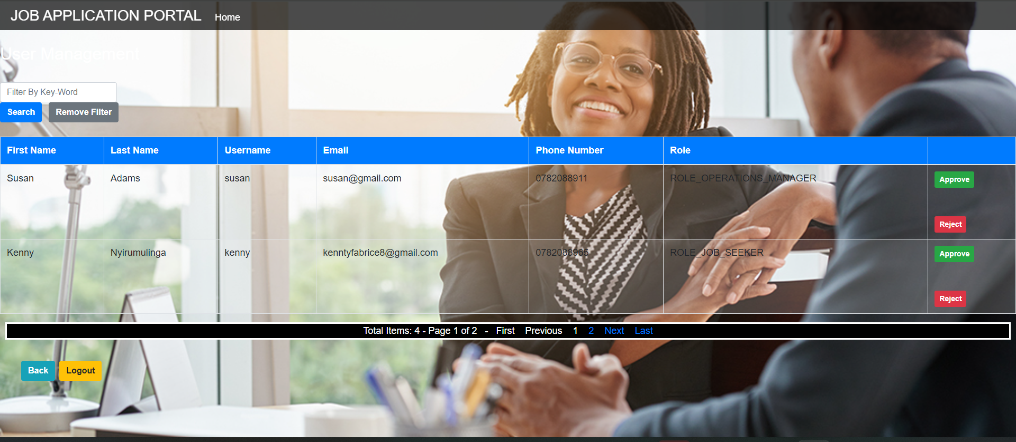

If user account get approved or rejected, it’s corresponding user will get a short email that his/her account has been approved or rejected.

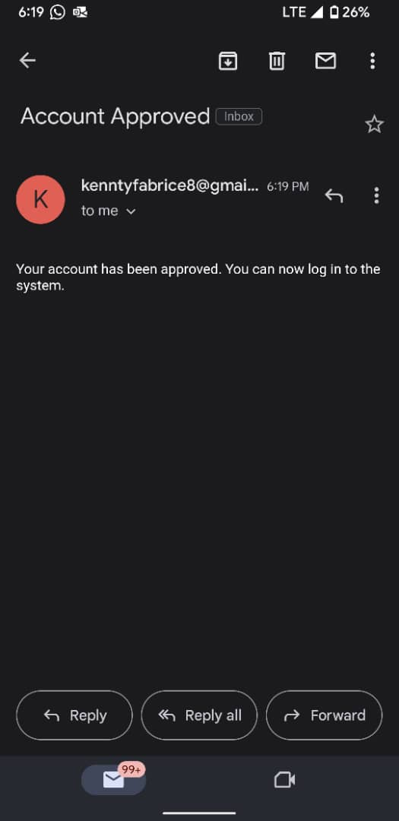

**ERROR HANDLING PAGE**

What if you try to access the wrong URL you will get this error message

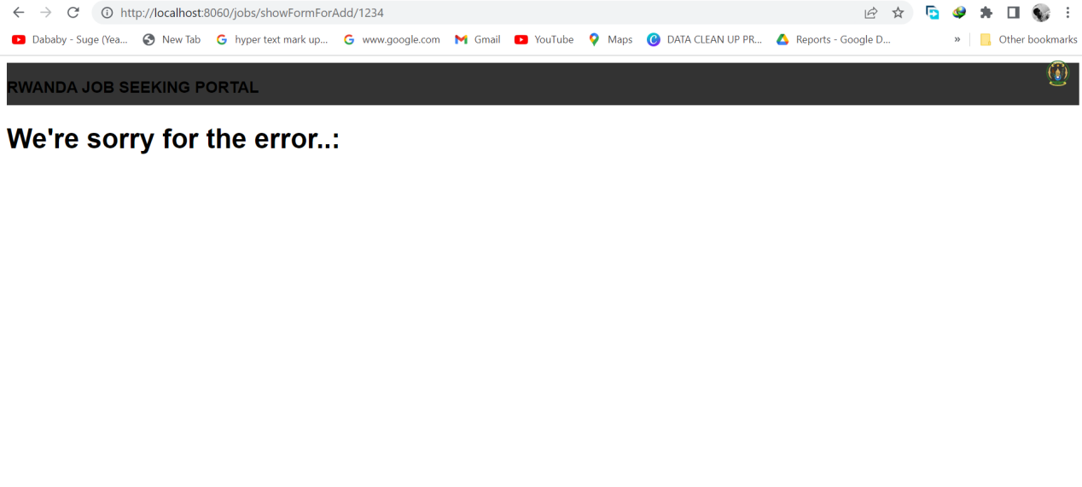

**6 . Techinical Documentation**

**Architecture of the application**

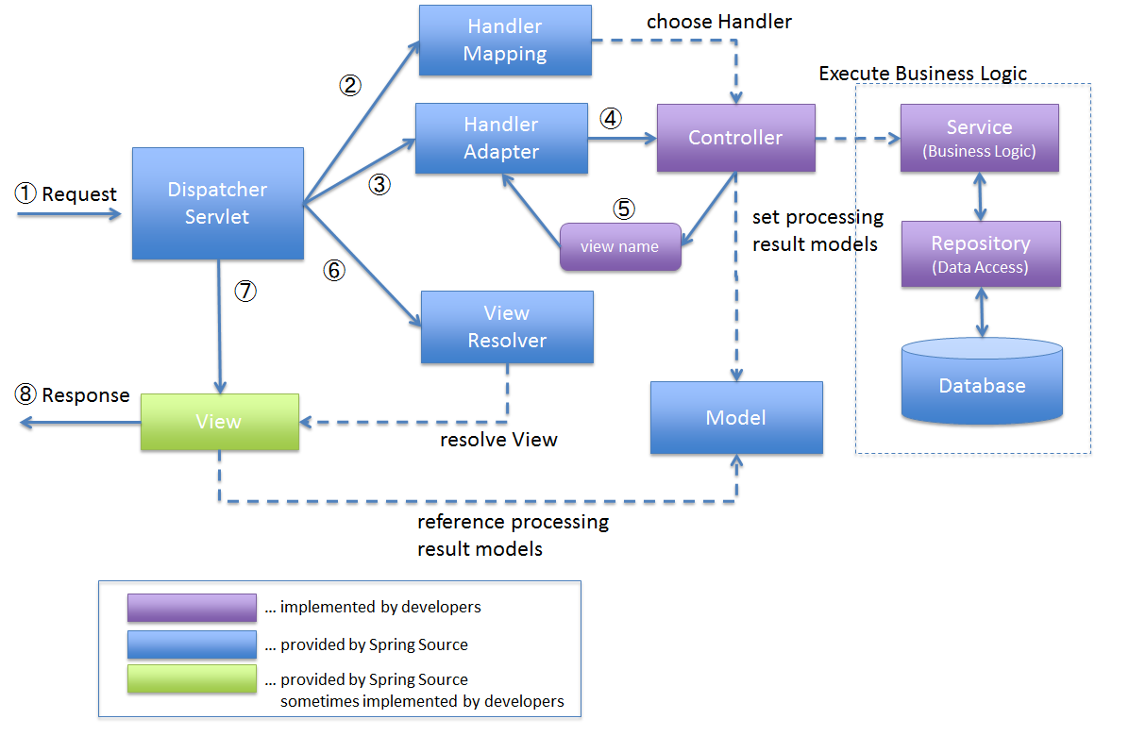

To implement this architecture, I developed a springboot maven application using spring starter IO. ➢

* I added a dependency of “spring-boot-starter-web”. This dependency includes the necessary libraries for creating web applications with Spring Boot, including the DispatcherServlet. The DispatcherServlet is automatically registered and configured when you include the necessary dependencies in your Maven pom.xml file and annotate your application's main class with @SpringBootApplication.
* I added a dependency of “spring-boot-starter-thymeleaf”. The Handler-Mapping is responsible for mapping incoming requests to the appropriate controller methods based on defined mappings and rules. It helps determine which controller should handle a specific request URL. When you include the spring-boot-starter-web and spring-bootstarter-thymeleaf dependencies in your Maven pom.xml file, Spring Boot automatically configures the Handler-Mapping as part of its auto-configuration.
* I have a three Controller classes namely, “LoginController”, “UserController”, “EmailController”, and “JobController”. The User controller is used to handle requests that are related to signing up new users to the system and setting their roles, the User controller is used to handle requests related to logging in, and password resetting. The Main controller is used to handle requests related to CRUD operations that are to be performed on the main domain model which is the construction projects
* I have the service layers that is an intermediate layer between the controller layer and the data access layer (typically represented by repositories or DAOs). Its main purpose is to encapsulate the business logic of the application and provide a separation of concerns. In my application, I used the userService layer to handle the business logic related to users of the application. Also, I have a jobService layer that handles the business logic related to construction projects persisted on the application.
* ➢ I have used the Spring Data JPA framework mainly the interface called JpaRepository by adding the dependency “spring-boot-starter-data-jpa”. JpaRepository is one of the central interfaces provided by Spring Data JPA. It extends the standard CrudRepository interface and provides additional methods for common database operations such as querying, saving, updating, and deleting entities. JpaRepository also supports pagination, sorting, and other convenience features
* The view resolver in Spring Boot resolves the logical view names returned by the controller methods to the actual view templates that will be rendered and returned to the client. When you include the spring-boot-starter-thymeleaf dependency in Maven pom.xml file, Spring Boot automatically configures the view resolver as part of its autoconfiguration.
* ➢ Spring-boot-starter-validation is a starter module in Spring Boot that provides support for validation using the Java Bean Validation API. It simplifies the configuration and usage of validation in your Spring Boot application by automatically setting up the necessary components.
* ➢ Spring Cache: Spring Cache is a caching abstraction provided by the Spring Framework. It allows you to add caching annotations, such as @Cacheable, @CachePut, and @CacheEvict, to your methods
* Spring Security: Spring Security is a comprehensive security framework for Java applications. It offers a wide range of features for securing web applications, including authentication, authorization, and various security mechanisms.
* ➢ MySQL-connector-java: mysql-connector-java (MySQL Connector/J) is the official JDBC driver for connecting Java applications to MySQL databases.
* Spring Email : Spring Email is a module within the Spring Framework that provides support for sending emails in Java applications. It simplifies the process of sending emails by offering a high-level abstraction and integration with various email providers.